**Beckhoff Web Socket Client**

Content

1. general process description 3

2. engineering 3

2.1 design 3

2.2 Testing 3

3. terms and conditions 3

3.1 quotation is valid 3

3.2 delivery time 3

3.3 payment terms 3

4. pricing 4

4.1 Software implementation 4

4.2 Testing and configurations 4

# general description

Purpose of Websocket Ads app is to enable websocket client access to [read or write] Beckhoff variables. This software is test by using

Twincat3 3.1.4024.22 version. Websocket Ads app is written with C#

vs2022 using .net framework 4.5

# short app description

Websocket sends data to “Websocket Ads app” in simple json format.

WA app receives data and creates object to be used to change or read

the content of different types of plc variables

# connection configurations

## Websocket IP / port

***Websocket IP / Port configuration is done in “SocketData.txt” located in same folder as .exe is located***

* *Example of local connection: "ws://Localhost:7890"*
* *Example of global connection: "ws://192.168.10.102:7890*

## Beckhoff ads server ip / port

***Beckhoff Ip / Port configuration is done in “Ads.txt” located in same folder as .exe is located***

* *Example of connection when app is running on same computer as Beckhoff program 127.0.0.1.1.1,851*

# using the app

1. *Copy Websocket Ads.exe bin folder to same pc in which Beckhoff program is running*
2. *Start Websocket Ads.exe*

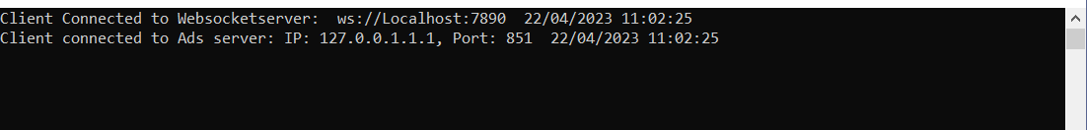

*If configuration is correctly done, above view is shown by console*

# Read values from beckhoff variables

*Note: Variable name has to exist in PLC and has to be corresponding type*

*READ FROM BECKHOFF VARIABLES - EXAMPLES*

* *If variable access is successful server will echo same message back + the value field with variable value.*

## send variable read command format

*Example 1:*

*{*

*"AccessType": "read",*

*"VariableType": "int",*

*"VariableName": "HMI.iTest",*

*}*

*Example 2:*

*{*

*"AccessType": "read",*

*"VariableType": "bool",*

*"VariableName": "HMI.bTest",*

*}*

*Example 3:*

*{*

*"AccessType": "read",*

*"VariableType": "float",*

*"VariableName": "HMI.fTest",*

*}*

*Example 3:*

*{*

*"AccessType": "read",*

*"VariableType": "string",*

*"VariableName": "HMI.sTest",*

*}*

## receive variable read command response from websocket server

*Example 1:*

*{*

*"AccessType": "read",*

*"VariableType": "int",*

*"VariableName": "HMI.iTest",*

*"Value": 101,*

*}*

*Example 2:*

*{*

*"AccessType": "read",*

*"VariableType": "bool",*

*"VariableName": "HMI.bTest",*

*"Value": "FALSE",*

*}*

*Example 3:*

*{*

*"AccessType": "read",*

*"VariableType": "float",*

*"VariableName": "HMI.fTest",*

*"Value": 1001,*

*}*

*Example 4:*

*{*

*"AccessType": "read",*

*"VariableType": "string",*

*"VariableName": "HMI.sTest",*

*"Value": "John",*

*}*

# Write values to beckhoff variables

*Note: Variable name has to exist in PLC and has to be corresponding type .*

*If variable access is successful server will echo same message back.*

## send variable send command format

*{*

*"AccessType": "read",*

*"VariableType": "int",*

*"VariableName": "HMI.fTest",*

*"Value": 11,*

*}*

*Example 2:*

*{*

*"AccessType": "read",*

*"VariableType": "bool",*

*"VariableName": "HMI.bTest",*

*"Value": "TRUE",*

*}*

*Example 3:*

*{*

*"AccessType": "read",*

*"VariableType": "float",*

*"VariableName": "HMI.fTest",*

*"Value": 1000,*

*}*

*Example 4:*

*{*

*"AccessType": "read",*

*"VariableType": "string",*

*"VariableName": "HMI.sTest",*

*"Value": "Test",*

*}*

*FORMAT OF SUCCESFUL WRITE RESPONSES*

*{*

*"AccessType": "read",*

*"VariableType": "int",*

*"VariableName": "HMI.iTest",*

*"Value": 11,*

*}*

*{*

*"AccessType": "read",*

*"VariableType": "bool",*

*"VariableName": "HMI.bTest",*

*"Value": "TRUE",*

*}*

*{*

*"AccessType": "read",*

*"VariableType": "float",*

*"VariableName": "HMI.fTest",*

*"Value": 1000,*

*}*

*{*

*"AccessType": "read",*

*"VariableType": "string",*

*"VariableName": "HMI.sTest",*

*"Value": "Test",*

*}*

## receive variable send command response

Format equals variable send command format

# Testing the app

. Simple web socket client for chrome is used for testing the application.

Example of sending write command to web socket server

Note console log information below

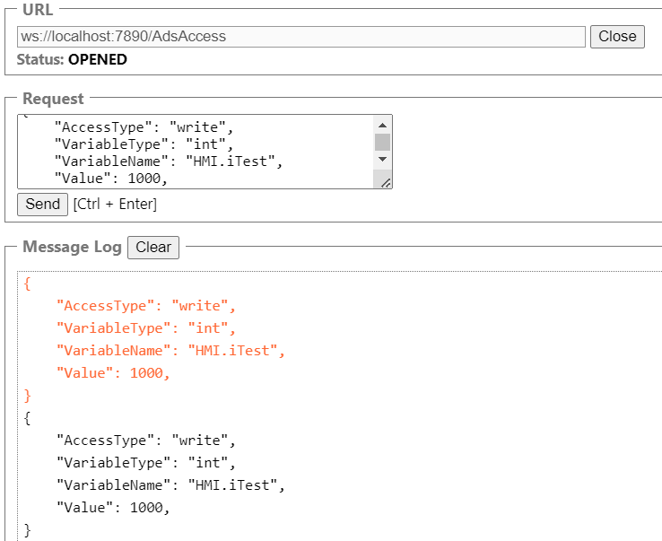

# variables viewed in beckhoff hmi program

[Program name.variable name]

Below example shows variables which are defined in program named “HMI”.

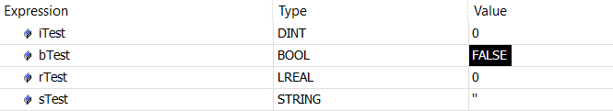

So to access those variables by web socket client see above examples of reading and writing to variables.